**MKT542- Digital Marketing Analytics**

**End-of-Course Assessment - January Semester 2023**

|  |  |
| --- | --- |
| Name | Sruthi Madhusudanan |
| Submission date | 28/04/2023 |

Table of Contents

Representative consumer profile and her decision journey map. 2

**Representative Consumer profile / persona** 3

**Customer decision journey map** 3

Objectives of the campaign, and how the campaign fits in different stages of the customer decision journey. 4

**Campaign 1:New member price discount** 4

**Role of campaign in CDJ** 6

Digital marketing channels 7

**Emails** 11

**Strength** 11

**Weakness** 12

**Facebook** 12

**Strength** 12

**Weakness** 13

**Branded search** 13

**Strength** 13

**Weakness** 13

**Data analytics to optimize channel performance.** 14

Consumer insights 18

**Findings from the simulation case** 18

**Traffic acquisition insights** 18

New campaign that enhances marketing performance 19

**Partnerships with fitness centre or gyms and holiday promotions** 19

References 21

Representative consumer profile and her decision journey map.

## **Representative Consumer profile / persona**

Meet Linda, a health conscious & fitness enthusiasts based in US. With a moderate level of tech savviness Linda is keen on tracking her daily physical activity and follow healthy dietary plans. With hectic work schedules she finds it difficult to track her physical activity.

**Name :** Linda

**Location** **:** US

**Mind-set :** Health conscious & Physical fitness enthusiasts

**Tech Savvy :** Moderate

**Goals**

To track daily physical activity

Follow diet plans

Maintain healthy lifestyle

**Worries About**

Couldn’t actively track physical activities due to work schedule.

No proper diet plans

**Concerns**

Safety

Cost

Balance between work schedule and exercise

**Content Needs**

Finding out how to achieve her goals

Finding best device for tracking

**Where to reach her**

Instagram

Facebook

Email

WhatsApp

Friends & family

Fitness group

Health group

Twitter

## **Customer decision journey map**

*Figure 1 : Customer decision journey map*

# Objectives of the campaign, and how the campaign fits in different stages of the customer decision journey.

I will evaluate the objectives of two campaigns namely new member price discount that were launched through year 1 to year 3.

## **Campaign 1:New member price discount**

*Figure 2 : Campaign background*

New member price discount campaign is launched during year 1 , year 2 and year 3 .This campaign focused on encouraging new signups by offering heavily discounted Smartwatches to the customers. The acquisition of new customers was the campaign's primary goal. When compared to the other campaigns in the year 3 campaign, it can be shown from the A/B testing (figure 3)that the "New Member Price Discount Campaign" generates the highest number of new customers from marketing. With an investment of $10,000 for each campaign and a 5% population size, we were able to track the amount of new customers for each campaign, with the New Member Price Discount Campaign bringing in the most. Similar to years 1 and 2, this campaign was most successful in achieving its goal. In all the three years more budget was allocated to this campaign.

*Figure 3 : A/B testing of Year 3 Campaigns*

### **Role of campaign in CDJ**

New member price discount campaign with its goal as “ New customer Acquisition” fits into Awareness , consideration and purchase stage.

|  |  |
| --- | --- |
| ***Stages*** | ***Influence of Campaign*** |
| Awareness | In this phase , customers become aware about smartwatch through thorough online search ,while marketing efforts such as ads, social media posts, and other promotional activities also draw them towards the brand. |
| Consideration | In this phase customers start to evaluate the smartwatch which they became aware of. The campaign can encourage customers to consider the device by highlighting unique features of the device .Discounted price makes it more attractive, increasing the chance of purchase. |
| Purchase | In this phase being aware of the discount , customers purchase the smartwatch , giving them the sense of value for money .At this phase further customer relationships are built which will evolve into loyalty over time. |

# Digital marketing channels

There are 5 channels through which campaigns were launched over 6 years, where each channel differs in the effectiveness. While the decision to use specific channels should come from customer insights, it’s important to understand what each channel has to offer. (D, 2023) Knowing the strength and weakness of each channel is crucial. It is important to analyse channels that help to generate quality leads and at what cost. From the simulation case lets analyse effectiveness of various channels by looking at channel impressions , website visits and CTR.

*Figure 4 : Year 1 Channel Impressions and CTR*

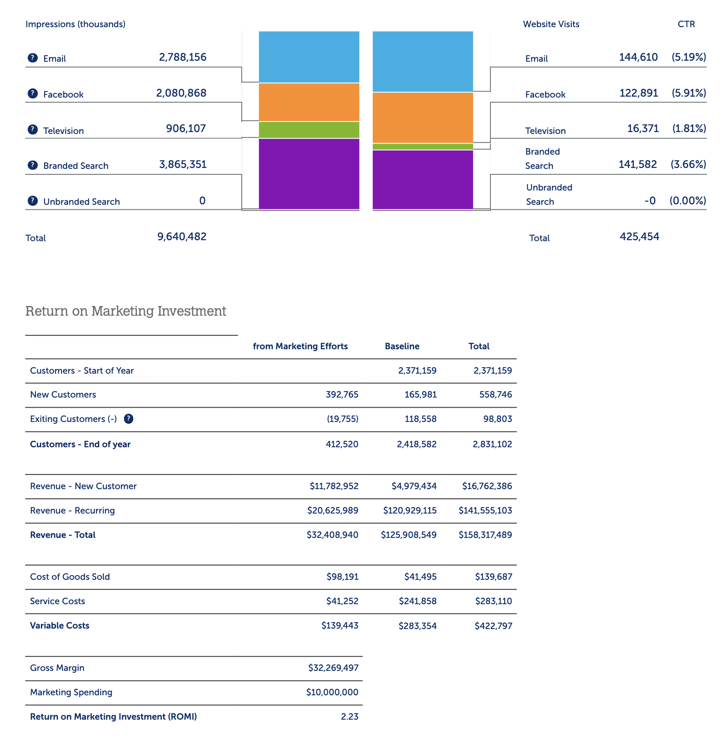

*Figure5 : Year 2 Channel Impressions and CTR*

*Figure 6 : Year 3 Channel Impressions and CTR*

*Figure 7 : Year 4 Channel Impressions and CTR*

*Figure 8 : Year 5 Channel Impressions and CTR*

*Figure 9 : Year 6 Channel Impressions and CTR*

**CTR and CPM**

*Figure 10 : Year 1 CPM and CTR*

*Figure 11 : Year 2 CPM and CTR*

*Figure 12 : Year 3 CPM and CTR*

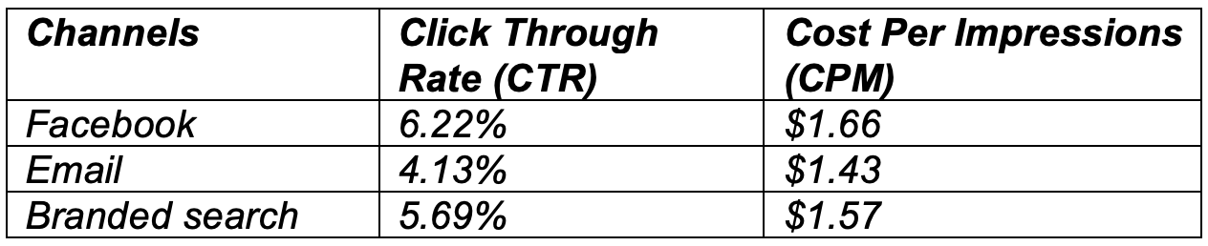

*Figure 13 : Year 4 CPM and CTR*

*Figure14 : Year 5 CPM and CTR*

*Figure 15 : Year 6 CPM and CTR*

## **Emails**

It could be noted from the above figures that at the end of 6 years Facebook, email and Branded search has proven to be the most effective channels.

*Figure 16 : Email data across years*

### **Strength**

**Feasible CPM**

Email is the cost-effective way of communicating with large number of people. According to Statista, global email usage will reach 4.48 billion users in 2024, up 580 million from 2018. (D, 2023). Since the CPM is low when compared to Facebook, this channel can be used to generate high ROMI.

**Targeted campaign**

93.6% of age 25-44 are active email users in the US. With continued advances in personalization, customization and consumer reach, email being the low-cost method can generate leads and increase revenue. (Indeed, 2023). By analyzing all these factors, we have invested in email as it is considered as an effective channel to promote product launches and sales of ExerciseMinder smartwatch.

**Create brand awareness and increase customer base.**

By creating content tailored to readers that further showcases the brand, product or services in a way that encourages a consumer to convert to a buying customer.

**High Click Through Rate (CTR)**

CTR refers to the ratio of clicks on a company's advertisement to impressions. It evaluates how well an email channel works to persuade recipients to click on a link and act. The greater the CTR, the more effective the channel is at engaging recipients and motivating them to do the desired action. The average CTR of Email throughout 6 years is relatively good when compared to unbranded search and Television.

### **Weakness**

**Design Problems**

Multiple devices display email differently, hence designing email marketing in such a way that it appears identical in all devices is difficult. While emails can’t display images, videos etc.

**Spam**

Commercial email or 'spam' makes consumers uncomfortable. The recipient may delete or unsubscribe emails if it’s not targeted at the potential customers.

**Undelivered emails**

Emails that are poorly designed may not be delivered. Email’s containing spam terms lor characters will fall into spam folder.

## **Facebook**

*Figure 17 : Facebook data across years*

### **Strength**

**Click Through Rate (CTR)**

Facebooks CTR is the highest of all channels. Its CTR is considered as one of the major strengths of Facebook. The targeted advertising capabilities of Facebook allows companies to reach specific audiences based on factors such as demographics, interests, and behaviors.

**User Friendly**

The user interface of Facebook is easy for placing Ads. By posting links of the company’s website on Facebook , we can increase online visits to the website . Facebook 'likes' is the start point to gather sales leads.

**Reach**

Facebook is the famous social media, with 2.96 billion monthly active users as of 2023. This provides vast potential customers to ExerciseMinder which helps to increase the installer base and hance the revenue. Further social media metrics like shares, likes etc. also increases brand awareness and engagement.

### **Weakness**

**Ad blockers**

Facebook users at times will be irritated by ads and might enable ad blocker which results in ineffective campaign efforts.

**High CPM**

Among all the channels given in the simulation case It could be observed that Facebook’s CPM is the highest. Though the CTR of Facebook is high, investing more in this channel would affect the ROMI as it has high CPM.

## **Branded search**

*Figure 18 : Branded search data across years*

### **Strength**

**Low CPM and High CTR**

Branded search has been used as an effective channel through 6 years due to its high CTR compared to Unbranded search and Television and low CPM , which resulted in good ROMI.

**Immune to ad-blocking software**

Search ads are non-intrusive and immune to ad-blocking software, which make it effective as it increases the company’s website traffic and leads.

### **Weakness**

**High competition**

One major weakness of branded search is the high competition for bid of brand keywords. if a competitor company bids the same keyword, then it will reduce the reach of the campaign. (Wlosik, 2022)

**Less effective for less-known brand**

Branded search occurs when customers are aware about the brand and want to purchase products or check for any deals /promotions or to compare prices etc. But if the brand is not well known, customers often choose the famous brand. So branded search is less effective when compared to the above channels.

Hence Emails, Facebook, and Branded search are found to be effective when simulation case data are analyzed. And more investments are done on Emails and Facebook and less on Branded search.

## **Data analytics to optimize channel performance.**

From the above insights obtained from the above data, we could use data analytics like regression and A/B testing to optimize the performance of channels.

Regression and A/B testing of Year 2

**Regression**

*Figure 19 : Regression analysis of Impression vs new customers*

*Figure 20 : Regression analysis of Impression vs new customers*

*Figure 21 : Regression analysis of Impression vs new customers and Impression vs website visits*

**A/B testing**

*Figure 22 : A/B testing*

Based on the insights obtained from Regression and A/B testing, campaigns are launched to enhance the performance of channels.

*Figure 23 : Year 2 Campaigns*

# Consumer insights

## **Findings from the simulation case**

Emails, Facebook, and Branded search are found to be effective when simulation case data are analyzed.

Here I have analyzed following data from google demo over 28 days and combined it with simulation case data to generate new consumer insight.

## **Traffic acquisition insights**

*Figure 24 : Traffic Acquisition*

Here it could be inferred that direct, organic search and cross network has the highest traffic.

While we know branded search may contribute to organic search traffic here it could be understood that organic search is preferred by customers like the branded search channel’s effectiveness in simulation case. Organic search results are unpaid that are displayed on a search engine results page. Of all website traffic 51% comes from organic search and organic traffic contributes over 40% of revenue. (Riserbato, 2020)

While direct traffic means visitors manually clicking the URL of the website or on a bookmarked link. (Miller, 2022). Direct traffic contributes the highest traffic. Email marketing results in direct traffic. When a campaign is launched with email as a channel which consists of link for the company’s website, when link is clicked it contributes to direct traffic. Thus, increasing website visits which has the potential for conversion.

Hence we could understand that costumers does more direct and organic search , which is an important finding which could be utilized in future to direct the marketing campaigns in suitable channels.

# New campaign that enhances marketing performance

## **Partnerships with fitness centre or gyms and holiday promotions**

Primary goals of the simulation case are an average ROMI of 3.0 or higher and a 200% increase in installed base, we have achieved an average ROMI of 2.1 and a 103% increase in installed base( from 2,371,159 to 4,830,917). To achieve these primary goals we can also incorporate a new campaign “**Partnerships with fitness centre or gyms and holiday promotions**” which has the potential to drive the installer base.

**Business objective**

New customer acquisition, Brand awareness, Increase installer base.

**Channels**

Emails can be used for existing customers,

Customers of partnered gyms and fitness centers,

Social media advertising in Facebook, Instagram, TikTok,

Gym and fitness store display

Affiliate marketing

**KPIs**

Annual ROMI,

Number of Smart watches sold ,

Annual revenue ,

Number of Impressions ,

Number of website visits ,

CTR

Social media metrics (i.e. ,Intermediate metrics likes , shares , comments ,retweets )

**Segments**

Physical fitness enthusiasts who go to gym frequently and fitness freaks who are looking ways to track their daily activity.

Customers who wants to buy a smartwatch as a gift during holiday season .

**Data to be collected and analyzed.**

**Data related to social listening:** Track social media channels for mentions of

Brands, products, and keywords related to new campaign could help us to measure the success of campaigns.

**Sales of Smart watch during the promotion period:** This is the Crucial KPI for the knowing the Campaigns success. By comparing the number of smartwatches sold during promotion period and before promotion period , we could know the effectiveness of the campaign . If the number is higher than the baseline customer base then we could infer that the campaign was successful .

**Impressions, CTR, CVR :** As we know

* Impression means the number of times ads are shown (impressions) or the

number of unique users who saw the ad (reach). A metric that measures your ability

to get in front of your audience.

* CTR means the number of times an ad was clicked compared to the number of impressions.
* CVR is the percentage of clicks that convert into leads.

By knowing the number of impressions and CTR we could determine effectiveness of social media channels in driving traffic to its website. Having high CVR could be considered an important data for determining the effectiveness of the campaign.

**Search engine traffic:** Search engine traffic refers to the number of costumers that are being directed to the company’s site by search engines. (Measuring Digital Marketing Effectiveness, n.d.)

**Customer Retention Rates:** Comparing the number of customers retained from marketing before launching this new campaign provides insights about the progress of campaign. From the simulation case, the number of exiting customers is 152,644 for the 6th year, the number of exiting customer must be less than 6th year which indicates the success of the campaign.

# References

D, P. (2023, January 31). *Digital Marketing Channels: Effectiveness and Best Practices*. Retrieved from https://adsterra.com/blog/digital-marketing-channels/

Indeed. (2023, February 4). *9 Types of Effective Digital Marketing Channels To Consider*. Retrieved from https://www.indeed.com/career-advice/career-development/digital-marketing-channels

Roomi, M. (2020, December 25). *7 Advantages and Disadvantages of Facebook Advertising | Drawbacks & Benefits of Facebook Advertising*. Retrieved from https://www.hitechwhizz.com/2020/12/7-advantages-and-disadvantages-drawbacks-benefits-of-facebook-advertising.html

*Facebook for business Advantages and disadvantages of Facebook for business*. (n.d.). Retrieved from https://www.nibusinessinfo.co.uk/content/advantages-and-disadvantages-facebook-business

Wlosik, M. (2022, June 7). *The Advantages and Disadvantages of Search Ads*. Retrieved from https://clearcode.cc/blog/advantages-search-advertising/

Riserbato, R. (2020, Febraury 25). *What's an Organic Search & How Do You Report on It?* Retrieved from https://blog.hubspot.com/marketing/organic-search-definition-100-words

Miller, C. (2022, November 30). Retrieved from The Difference Between Organic Traffic and Direct Traffic Website Sources: https://www.smartbugmedia.com/blog/what-is-the-difference-between-direct-and-organic-search-traffic-sources

*Measuring Digital Marketing Effectiveness*. (n.d.). Retrieved from https://www.lucidadvertising.com/blog/digital-marketing-effectiveness/

(n.d.). Retrieved from Email marketing Advantages and disadvantages of email marketing: https://www.nibusinessinfo.co.uk/content/advantages-and-disadvantages-email-marketing